Entries of MUMMA descendants found in the ministerial records of Rev. Henry B. Schaffner

[extracted and compiled by Douglas M. Mumma, revised 16 Jan 2006]

Background information about Henry B. Schaffner/Shaffner

Originals documents of his ministerial records can be found at the Evangelical and Reformed Historical Society, 555 W. James St., Lancaster, PA USA 17603 http://www.erhs.info/webex/exhibit1/e10030a.htm
A copy of his record book is also located in the Lancaster County Historical Society, Lancaster, PA
The Reformed Historical Society entry about his ministerial records state:
Abstract This collection contains original pastoral records including baptisms, marriages, confirmations, deaths from 1820-1847 some of this information is in German. There is a record of preaching 1807-1830, writings in German and marriage records.
Admin/Biog History Henry B. Schaffner was born on April 5, 1784. There is no mention of where he was born. His father was Henrich Schaffner and his mother was the former Anna Christina Bleetz. He was licensed and ordained in 1808 by the Synod of the U.S. in Germantown PA. He served many congregations such as Reformed Church in Maytown 1808-1838, Trinity Reformed Church in Columbia 1808-1840, Zion Reformed church in Marietta and Manheim UCC. He also served congregations in Elizabethtown and Rapho. These congregations were part of the Lebanon Classis and later a part of the Lancaster Classis.
In 1840 Henry B. Schaffner was deposed with no record of re-instatement. He was dismissed by the Lebanon Classis on complaints of his congregation.
Towards the close of his life he was severely afflicted with gangrene in both of his feet. He died on April 19, 1852 in Marietta PA. and was buried at the Union Church in Marietta.

Additional information about the churches Henry Schaffner served and formed can be found at:
http://www.horseshoe.cc/pennadutch/religion/reformed/reformed.htm Extracted information follows:
“In 1805, the Maytown congregation united to build a new church, but as means available were not sufficient, Henry Haines, a member of the congregation, and also of the State Legislature, "had an act passed authorizing a lottery for building a German Reformed Church at Maytown." The highest prize was $1,000, and twenty-five hundred tickets at six dollars each were to net $15,000. The drawing was duly held and the grand prize of $1,000 was won by John Graybill, of Donegal township. He subscribed the whole amount to the Building Fund of Maytown Church. Cornerstone was laid in 1807, and the church, with bells and organ, was completed at cost of $3,292.76; the subscribed sum being only about seven dollars short of this amount. Thus the church entered upon a larger work under favorable conditions. The new church was dedicated in 1808, by Rev. Henry B. Shaffner, who had been assistant pastor under Rev. Hiester. Rev. Shaffner was appointed pastor, in 1808, and was continued in the charge until 1835. During that time he organized several other churches, one at Elizabethtown, in 1816, and one at Marietta, in 1818. Evening services were not held in Maytown until 1818. After leaving Maytown, in 1835, Rev. Shaffner continued as pastor of Marietta until 1840.

One of the very interesting things that Rev. Henry B. Shaffner included in his ministerial records were “life summaries” for many of the members of his Columbia congregation. While the records are generally quite accurate, any dates of birth, marriage or death which occurred prior to 1820 must carefully evaluated for accuracy since the happened prior to this date. These summaries contained information about a person's birth, baptism, marriage, number of children, death and even some small comments.

Because most of Schaffner’s entries were written in German, transcription and translation assistance was provided by of Dr. Roger P. Minert with German Research and Translation, Inc. He assisted with the transcription of the German into English as well as providing a literal translation. Mr. Rudolf Michaels of the Sacramento German Genealogy Society also provided confirming translations.

Scanned images of Schaffner’s record book are shown first, followed by a German to English transcription and then the translation.

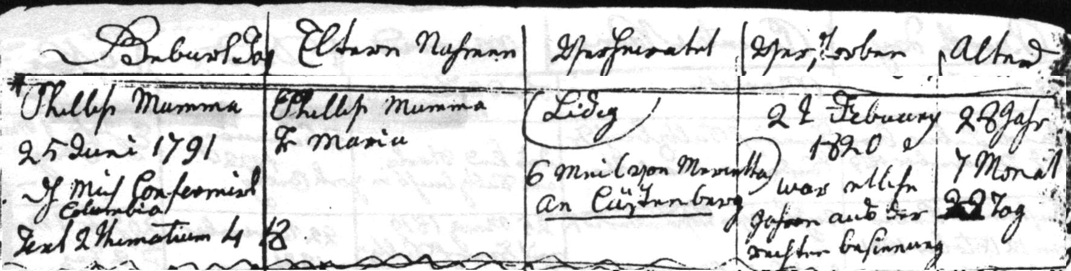

Phillip Mumma Phillip Mumma Ledig 22 February 28 Jahr
25 Juni 1791 Fr Maria 1820 7 Monat
dh mich confirmirt 6 Meil (von Marietta) war etliche 22 Tag
Columbia An Cästenberg Jahre aus der
Text 2 Thematium 4:18 rechten Besinnung

Phillip Mumma, the son of Phillip Mumma and his wife Maria, was born 25 June 1791. He was confirmed in Columbia by me. He lived six miles from Marietta on Castenberg Rd. He died 22 February 1820 at the age of 28 years, 7 months, and 22 days, after being out of his mind for several years. The funeral sermon was based on 2 Timothy 4:18.

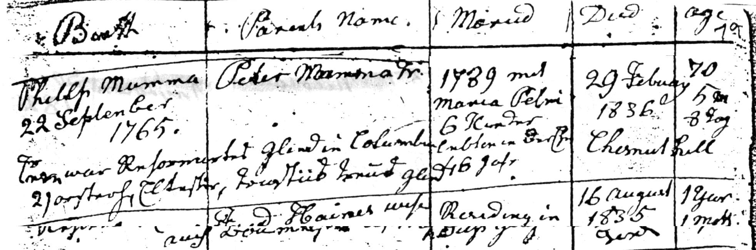

Philip Mumma Peter Mumma Fr 1789 mit 29 February 70
22 September Maria Petri 1836 5 M
1765 6 Kinder Chestnut Hill 8 Tag
Er war Reformirtes Glied in Columbia lebten in der Ehe
21 ?.. Eltester .?.. Treus Glied 46 Jahr

Philip Mumma was born 22 September 1765, the son of Peter Mumma and his wife. He married Maria Petri in 1789 and they had six children and were married for 46 years. He died at Chestnut hill on 19 February 1836 at the age of 70 years, 5 months, and 8 days. He was a member of the Reformed Church in Columbia. ..... an elder, and a faithful member.

the 22 May 1816 Johannes Mumma u Maria Weller in (Silver) Columbia
on 22 May 1816 Johannes Mumma and Maria Weller in (Silver) Columbia

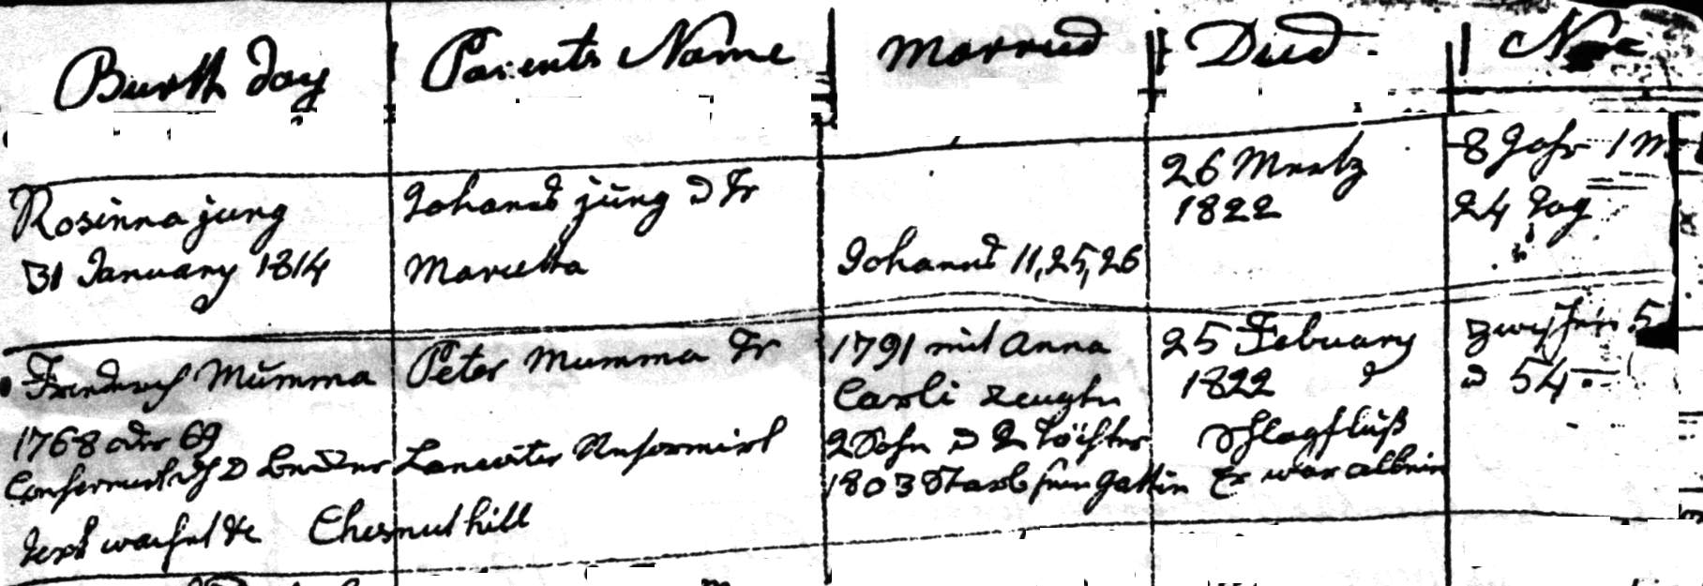

Frederick Mumma Peter Mumma Fr 1791 mit Anna 25 February zwischen 53
1768 oder 69 Carli zeugten 1822 und 54
confirmiert dh d. Becker Lancaster Reformirt 2 Sohn u 2 Töchter Schlagfluß
Text wachet ... Chestnut Hill 1803 starb seine Gattin Er war allein

Friederich Mumma was born in 1768 or 1769, the son of Peter Mumma and his wife. He was confirmed by Pastor Becker of the Lancaster Reformed Church. He married Anna Carli and they had two sons and two daughters. She died in 1803. He died of a stroke at Chestnut Hill on 25 February 1822 at the age of 53 or 54. He was living alone at the time. The funeral text was

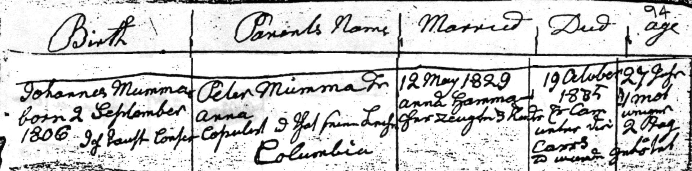

Johannes Mumma Peter Mumma Fr 12 may 1829 19 October 27 Jahr
Born 2 September Anna Anna Hamma- 1835 1 mot
1906 Copulirt u that seine Leiche cher zeugten 3 Kinder Er cam wenger
Ich taufte Confir Columbia Unter die 2 tag
Cows
Ud wurde getötet

Johannes Mumma was born on 2 September 1806, the son of Peter Mumma and his wife Anna. I [pastor] christened and confirmed him and presided over his wedding and his funeral. He married Anna Hammacher on 12 May 1829 and they had three children. He died on 19 October 1835 at the age of 27 years, one months less a few days. He had fallen under the cows and was trampled to death. [There is disagreement as to whether the transcriptions of his death should say cows or carts. From the tax records we learn that he had only 3 cows and was a teamster, probably working in the open pit iron mines. Being trampled under a team of horses while pulling iron ore seems more plausible than being “trampled” by his three cows. However, he could have been “kicked” in the head by his cow. Since Schaffner uses a mixture of German and English, the translation will be left to the imagination of the reader as to the exact cause of his death. Rudolf Michaels feels carts is more likely, however Roger Minert suggests that Schaffner would have likely written Wager or Raeder if he meant Cart]

