Christian Mumma Family Record

[This document is in the possession of possession of Carolyn Louise Johnson Rice of Springfield, Ohio. Carolyn is a descendant of Christian => Henry => Charles E. => Dorothy E. => Carolyn. The original author and the date it was written is unknown, but, because of style similarities, it was likely written by one person at the same time. Since Elizabeth was not literate, it must have been someone else.]

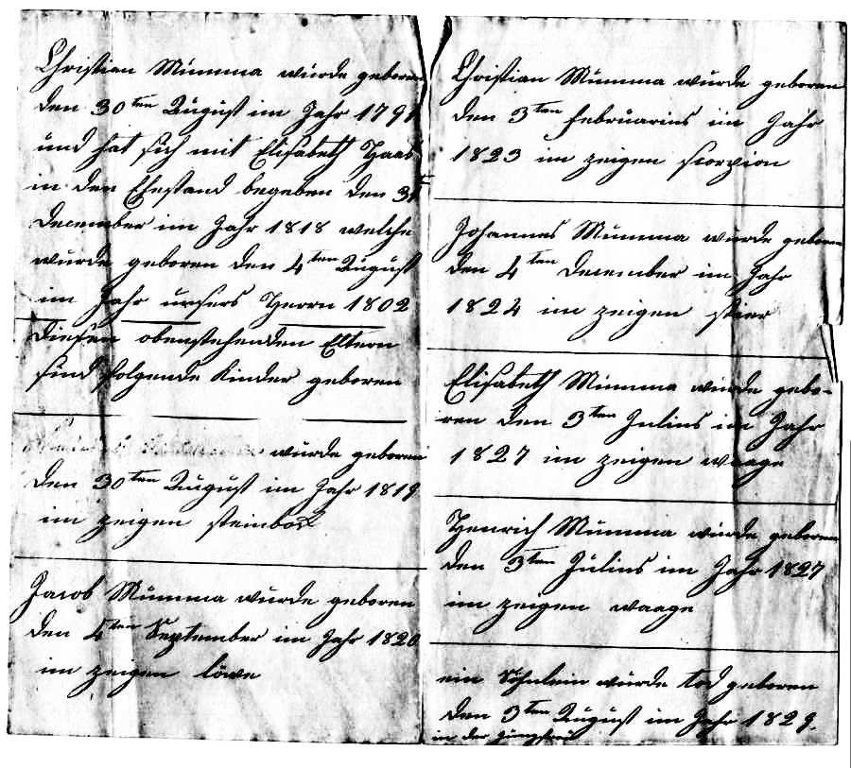

Document translated by Corinne Earnest of East Berlin, PA 17316

----------------------------
Christian Mumma was born
the 30th August in the year 1791
and gave himself in matrimony with Elizabeth Hass
on the 31st of
December in the year 1818
[Eizabeth] was born the 4th of August
in the year of our Lord 1802
--- ------ ------
These above mentioned parents
had the following children born
--- ------- -------
[name erased] was born
the 30th of August in the year 1819
in the sign of Steinbock (Capricorn)
------------------------------
Jacob Mumma was born
the 4th of September in the year 1820
in the sign of Löwe (Leo)
-------------------------------
Christian Mumma was born
the 3rd of February in the year
1823 in the sign of Scorpio
-------------------------------
Johannes Mumma was born
the 4th of December in the year
1824 in the sign of Taurus
--------------------------------
Elizabeth Mumma was born
the 3rd of July in the year
1827 in the sign Waage (Libra)
--------------------------------
Henrich Mumma was born
the 3rd of July in the year 1827
in the sign Waage (Libra)
---------------------------------
a little son was stillborn
the 3rd August in the year 1829
in the [sign of] Virgo
---------------------------------

