The Mumma Families of Butler and Preble Counties, Ohio

By Douglas M. Mumma
2123 Farmington Place
Livermore, CA 94550
doug@mumma.org
Revised 15 June 2010
Introduction and background

This document describes information discovered about the Mumma families of Butler and Preble Counties, Ohio. For several years, I had collected various bit and pieces of information about these families, but was not able to connect them together or know from whence they migrated. My interest was drawn to this project when I learned that a John Mumma was credited with having laid out the village of “Euphemia”, near Lewisburg in Preble County, Ohio in 1836. Since my own Mumma family arrived in Montgomery County, Ohio in 1827, I was surprised to find another Mumma family in nearby Preble County. I could not identify this John Mumma in my extensive MUMMA database of over 49,000 Mumma descendants when the search was begun. My curiosity was piqued.

Most of the data presented in this article was obtained from bible, census data, civil records and various histories published about Preble and Butler counties. I would like to thank Roy Wesley Mumaw for sharing with me the Mumma/Reppeto bible pages. These pages were given to Roy by an unknown gentleman about 1973 who we now believe descended from Elizabeth L. Mumma. In addition, I would like to thank Shari Cook of the Preble County Library and Sheila Aranyos of the Smith Library of Regional History in Oxford, Ohio who assisted in locating and providing Preble & Butler County documents which included the Mumma surname.

From whence did the Mumma family migrate?

The progenitor of this particular Mumma family has now been identified as John Mumma who migrated to Ohio from York County, Pennsylvania around 1832 (age 52). John’s grandfather and great grandfather arrived in Philadelphia on September 18, 1732 aboard the ship named the Johnson with other “German Huguenots”.

John Mumma is identified in the Pennsylvania census records as living in the Heidelberg Township of York County in 1810, 1820 and 1830. He appears in the 1840 census of Butler County, Ohio as living in Lemon Township (Middletown). He is identified as owning land, a house and distillery in Lemon Township of Butler County in the land re-assessment performed by James McBride in 1834. He is also listed as purchasing land in Preble County in January of 1834. In addition, John’s daughter, Amanda Mumma Henkel, is identified on pages 649-654 of the History of Butler County (http://www.rootsweb.com/~ohbutler/cyc/649.htm) as arriving in Butler County in 1832. So we can conclude that John and his family arrived in Ohio in the early 1830’s and began purchasing land in both Butler and Preble Counties. By 1834, John owned 383 acres and other improvements valued at $3263 in Lemon Township. Land value at that time was about $6-8 per acre and he would have been considered to be quite wealthy. He likely brought most of his wealth with him from York County, Pennsylvania.

John was born on April 10, 1780 as the eldest son of a John Mumma (1750-1839) who resided in the Heidelberg Township of York County, Pennsylvania. John married a Ann (Susanna?) Bowers in the early 1800s. This Mumma family was of the Mennonite faith and John (1750), is credited with having platted a town which he called “Mummasburg”, PA in 1820 with 150 lots using the services of John L. Hinkle (Henkel). In 1823, John (1750) convinced the Mennonites to move their place of worship from Flohr’s Church in Gettysburg to nearby Mummasburg where they built a meetinghouse. Abraham Mumma, a son of John (1750) is buried in the Mummasburg Mennonite Cemetery along with his wife and daughter. Also, John’s daughter, Maria Mumma married Bishop John Roth who was the first Mennonite Bishop west of the Susquehanna River and he lead the Mennonite fellowship in Mummasburg for many years. They too are buried in the Mummasburg Cemetery along with many of their descendants.

Where they settled.

Initially John Mumma, (1780-1849) settled in Lemon Township of Preble County with several of his children around 1832, including his eldest son, John Jr., who was born about 1809. His eldest daughter, Amanda, married a man by the name of Hiram Henkle (Hinkel) in York County, PA and they too moved to Butler County, Ohio.

Preble County - From the land records of Preble County, we learn that a John Mumma of Butler County, Ohio, purchased three pieces of land on January 2, 1834 from Jacob & Mary Bower of Indiana, which included an existing saw mill on Twin Creek in sections 34 & 26 of Twin Township. The cost was $5200 for about 190 acres. It is interesting to note that John’s wife’s mother’s maiden name was Bowers. This name similarity is probably just a coincidence. The Preble County records list the marriage of John Mumma to Mary Ann Blount on 11 Nov 1835. This is John Mumma, the eldest son, and the marriage date is confirmed from the bible records of the Reppeto and Mumma family. John and Mary Ann Mumma appear in the 1840 and 1850 census records as living in Twin Township of Preble County where they raised their family. In addition, a John Mumma is listed as laying out the town of Euphemia in Harrison Township in 1836 with 200 lots. This town was near the town of Lewisburg, into which it has since been absorbed. Various histories suggest that the town was named after John’s wife, but neither of the John Mummas wives were named Euphemia. Possibly Euphemia was a middle name or possibly of an unidentified wife. I don’t have sufficient evidence to determine whether it was John the father or John the son who platted this town, but most likely John the father. A review of the some of the deeds of Euphemia would possibly reveal a wife’s name when he sold any lots he may have owned. A review of the tax records from 1843 through 1850 reveals John Mummas being taxed. From the estate papers of John, Sr. we know the father remained in Butler County and his son lived and improved the land in Preble County. On 14 May 1844, John Sr. wrote a document in which he describes that his son, John, was living on a farm in Preble County that John Mumma Sr. owned, but that John Jr. was making improvements which should be appraised upon John Sr.’s death. After John Mumma Sr.’s death, the son did file an appraisement of improvements on this farm/mill in Preble County. John Mumma Sr.’s name disappears from the Preble County tax rolls after 1846.

John and Mary Ann Blount Mumma raised their family of 9 children in the Preble County. They can be found in 1840 & 1850 census records living in Twin Township. John operated a mill (called the Mumma Mill) and general store. In the History of Preble County, Ohio by H.Z Williams & Bro. 1881, it says regarding the Mumma mill, “This mill was a great convenience to settlers, who, before its erection had to go to Gunkle’s mill at Germantown in Montgomery County to get their grinding done.” The Gunkel (Gunkle) name of Germantown is of interest because another John Mumma, a nephew from Butler County, married a Gunckel girl of Germantown. The Mumma family does not appear in Preble County after the 1850 census. It is likely that all of the Preble County property owned by his father was sold upon the father’s death in 1849. Nothing is known as to where they migrated. A possible clue is one of the sons married a Josephine Reppeto from Miltonville in Butler County. Possibly John and his family migrated to Butler County. There is an entry on page 50 in the book “Twin Valley Tidbits”, 1995 by Audrey Gilbert which says, “the subscriber [John Mumma] being desirous of settling up his business, would respectfully request all who know themselves indebted to him , or the firm of Mumma & Bowers, either on the mill or store books, to call and settle the same”. This was published in the Eaton Democrat on October 31, 1850. Again, this suggests that the family was planning to leave the area, probably due to the death of his father and sale of the property. The family bible records the death of John Mumma as 21 June 1868, but no location was noted.

There are no death dates for the first three children, other than an entry of “died”. The last date entry on the bible page was in 1909 and maybe this was probably their status at that time. Neither Edward nor William appear in the 1850 census, so it is likely they died in their childhood.

The three younger sons, Ambrose B., John Rush and Charles R. Mumma all served in the Civil War for the Union Army. John and Charles both served with Company I of the 5th Ohio Cavalry. They entered as privates, but John was discharged as a corporal. Both of them filed pension papers in the 1870s after they migrated to Kansas City, Missouri. Ambrose, the eldest, served with Company G of the 12th Ohio infantry as well as Company E of the 34th Ohio infantry. Ambrose was killed on 23 June, 1863. The bible record suggests he died at the “Battle of Wittfield”, but regimental records do not mention such a battle.. It is unknown where Ambrose is buried. These military pension and service records can be viewed on the Internet at the Ancestry web site.

Butler County - We will now focus our attention back to Butler County where the elder John Mumma (1780) lived with his other children. He established an important grain mill in Middletown on the west side of the Miami River in Madison Township. The mill packed 4000 barrels of flour and ground 45000 bushels of grain each year which is recorded in “The Economic Development of Middletown Ohio 1796-1865”. In another part of this document, it says that John Mumma bought his mill around 1840. In addition, John Mumma made plats of land around Middletown from his extensive land holdings.

John had extensive vineyards which produced wine and distilled gin. At the estate sale, various barrels, stills and other wine/distilling equipment were sold, along with 316 gallons of gin were sold, as well as more than 115 gallons of wine.

One of the famous landmarks in Middletown was the Madison House which was located at Ohio and Front Street. This hotel was built by John Mumma, Sr. in 1846 in anticipation of the arrival of the Cincinnati, Hamilton and Dayton Railroad, which then had to buy land from John on which to lay tracks. The first locomotive arrived in September, 1851. It was a plain brick structure that was 2½ stories high and 72 by 21½ feet in extent. It contained 30 rooms above ground and 11 in the basement. It was continually improved and had many porches and ballrooms for dancing. From the some of the writings of the local history, we learn that the proprietor in the early 1850’s was a Louis Wagner, suggesting that John sold his holdings, or since he died in 1849, then it is likely it was sold by his estate.

The final accounting of John’s estate filed on 14 June 1853 showed his estate valuation as follows:
Personal property appraisement/sale $2,997.66
Value of notes & receivables $5,227.38
Notes & property not appraised $4,419.42
Proceeds from sale of real estate $8,516.00
Interest received $189.66
$21,350.12
John would have been considered wealthy with an estate this large.

Not much is recorded about John’s two sons who remained in Butler County. From the 1850 census of Madison Township, we know that David Mumma (1825-1879) was listed as a “Miller”, likely working in one of the local mills, possibly his fathers. Next door was living his brother, Daniel Mumma (1824-1853), a farmer. Living adjacent to Daniel was his sister and brother-in-law, Hiram and Amanda Mumma Hinkle. This was likely land their father had purchased.

Daniel died in 1853 at the young age of 29 from unknown causes leaving his wife, Caroline, with three young children to raise by the name of Florence, John and Mary. Mary died within a year. The 1860 census for Madison Township reveals that Caroline has remarried to a fellow by the name of Jacob Vorhiss. Her remaining two children, Florence and, are living with their mother and step father. In 1876, John, marries a girl by the name of Emma Gunckel from Germantown in Montgomery County, Ohio and they soon have a child by the name of John Vernon Mumma in 1877. By the 1880 census, John the father, has died and his wife, Emma, is living in the household of her parents in Germantown. As if enough tragedy didn’t happened to this family, John Vernon Mumma’s mother, Emma dies within a short time period and he is raised as an orphan by his grandparents. He marries in 1898 in Dayton Ohio and he has a large family of eight girls and two boys. By the 1920’s, the family has departed from Dayton for various parts of California, Nevada, and Utah. A descendant’s tree which includes this extensive family is attached as the last pages of this report.

Little is known about the youngest son, David and his family. From the 1850 and 1860 Madison Township census records, we know that he had two children. He and his wife, Elizabeth, were not found in the 1870 census. David died in 1879 and was buried in the Middletown Pioneer Cemetery. His oldest son, Samuel, born in 1850, married a girl by the name of Florence and she appears in the 1880 census as a widow with two children by the name of Harry and Charles. Nothing further is known about these two boys. These were the only heads of household with the MUMMA surname indexed in the 1880 census.

John Mumma Sr. was most likely raised as a Mennonite with his family in York County, PA, but apparently didn’t follow this religion in Ohio. On page 632 of the Biographical Cyclopaedia of Butler County, John’s son, David Mumma, is listed as being an elder of the Presbyterian Church of Middletown. Apparently the original Presbyterian Church building was bought by the German Lutherans and a new building was built in 1856. Fourteen members of the Mumma family are buried in the old “Pioneer” Cemetery in Middletown.

DNA Testing
One of the descendants of this branch participated in the Mumma Surname DNA project. The analysis of his DNA was a perfect match to the MUMMA modal haplotype which confirms that this branch descends from one of the three Mumma families who migrated to America from Germany between 1731 and 1748. Work continues to connect this branch to one of these immigrants.

Summary

The Mumma family makes a brief appearance in Butler and Preble counties for about 30 years, from about 1832 to1860. The family was considered wealthy and influential in the development of the area around Middletown. The family began to disintegrate with the death of the progenitor, John Mumma, in 1849. Within a span of a few short years, several of the children and grandchildren died or moved from the area. After 1880, the name is only found recorded in the local history books and no one with the Mumma name lives in these counties today.
References
Mumma & Reppeto family bible – The current bible location unknown (images on pages 7 & 8)
U.S. Federal Census - 1800 PA York Co., Heidelberg Twp. p. 1344 Ancestry image #2
U.S. Federal Census - 1810 PA York Co., Heidelberg Twp. p. 131A Ancestry image #1
U.S. Federal Census - 1820 PA York Co., Heidelberg Twp. p. 58 Ancestry image #1
U.S. Federal Census - 1830 PA York Co., Heidelberg Twp. p. 227 Ancestry image #9
U.S. Federal Census - 1840 PA York Co., Heidelberg Twp. p. 22 Ancestry image #1
U.S. Federal Census – 1840 OH Butler Co., Middletown (Lemon) Twp. p. 140 Ancestry image #3
U.S. Federal Census – 1840 OH Preble Co., Twin Twp. p. 31 Ancestry image #169
U.S. Federal Census – 1850 OH Butler Co., Madison Twp. p. 342A Ancestry image #25
U.S. Federal Census – 1850 OH Preble Co., Twin Twp. p. 441 Ancestry image #425
U.S. Federal Census – 1860 OH Butler Co., Madison Twp. p. 314A & 314B Ancestry image #47 & 48
U.S. Federal Census – 1880 OH Butler Co., Middletown Twp. p. 105B Ancestry image # 78
U.S. Federal Census – 1880 OH Butler Co., Madison Twp. p. 150B Ancestry image #46 (Vorhis)
U.S. Federal Census – 1880 OH Montgomery Co., Germantown Twp. p. 467 Ancestry image #12
U.S. Federal Census - 1880 MO Jackson Co., Kansas City pp 254A and 404C
U.S. Federal Census – 1900 OH Montgomery Co., Dayton, ED85, Germantown Village. p. 163A Image #1
Estate record for John Mumma - Butler County, Archives, Hamilton - 1849 a-t9 p97
Middletown “Pioneer” Cemetery 1827-1987, Southwest Butler County Genealogical Society1987 .
Preble County, Ohio Land records, Vol IV, Recorded 1832-1838.
Butler County Land Assessments of 1834, by McBride (http://www.butlercountyohio.org/rca/lemontwp.pdf)
History & Biographical Cyclopaedia of Butler Co, OH 1882 (http://www.rootsweb.com/~ohbutler/cyc/index.htm)
The Economic Development of Middletown Ohio (http://www.middle-america.org/crout/Economic/ch_06.html)
Madison Township-Bicentennial Sketches1799-1999 (http://www.middle-america.com/crout/Madison/index.html)
Preble County’s Colorful Past, by Harry L. Hale, The Register- Herald, Jan 25, 1950.
Twin Valley Tidbits by Audrey Gilbert, 1995 pp 1, 2, 8, 11, 49, 50, 52, & 55
History of Preble County, OH by H.Z Williams & Bro. 1881 pp. 38, 212, 344 & ?
By Old Mill Streams by Seth S. Schlotterbeck 1986 Eaton, OH pp. 43, 44 & 46

Relationship of Middletown in Butler County with Euphemia in Preble County.
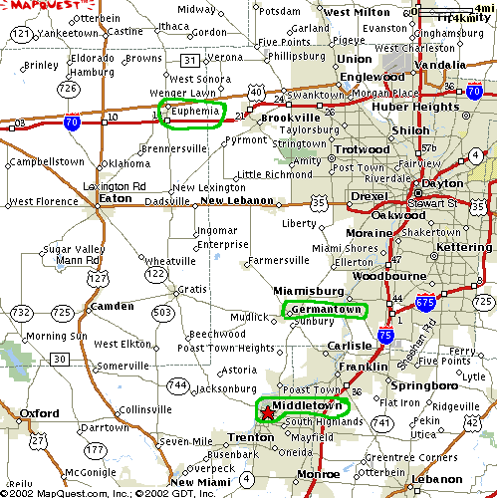
Preble County, Ohio Twin & Harrison Townships

[Map by Tom Midlam http://206.103.255.34/preble/harrison.htm]
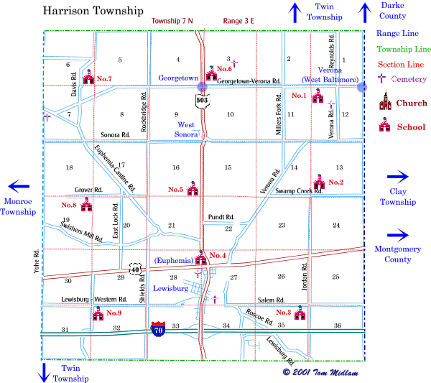

[Map by Tom Midlam http://206.103.255.34/preble/twin.htm]
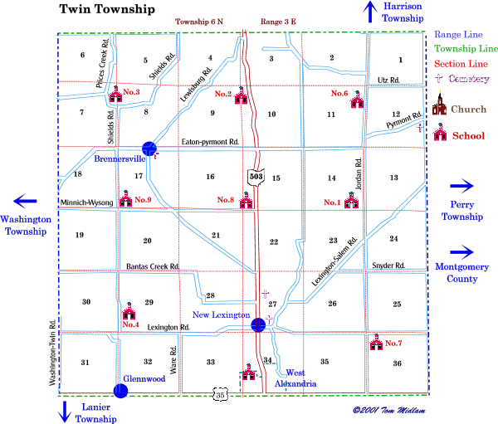
Butler County, OH

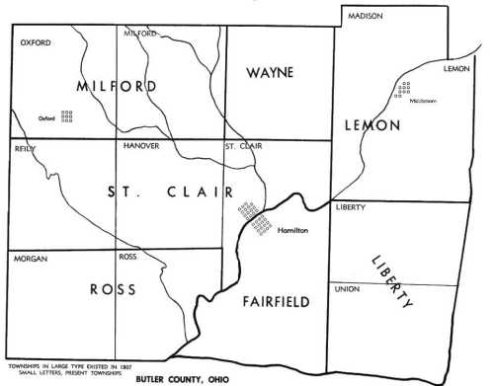

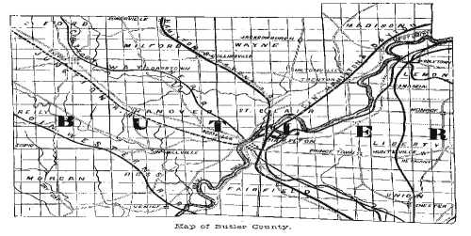
”Marriage Index: Ohio, 1789-1850”
Family Archive CD #400

Mumma, Eliza Married: Sep 24, 1833 in: Butler Co., OH Spouse: YOUNG, WILLIAM
[Extracted from Family History Library, Salt Lake City, UT, Film # 0355779.]

Mumma, John Married: Nov 11, 1834 in: Preble Co., OH Spouse: BLUNT, MARY ANN
Extracted from Family History Library, Salt Lake City, UT, Film # 0564963.

Mumma, Maria Married: Feb 17, 1835 in: Butler Co., OH Spouse: JACOBY, GEORGE
[Extracted from Family History Library, Salt Lake City, UT, Film # 0355779.]

Mumma, Anna Married: Feb 23, 1837 in: Butler Co., OH Spouse: CURRY, JAMES H.
[Extracted from Family History Library, Salt Lake City, UT, Film # 0355779.]

Mumm, Anna Married: May 06, 1839 in: Hamilton Co., OH Spouse: DONAHOE, GEORGE
[Extracted from Family History Library, Salt Lake City, UT, Film #s 0344451-0344463.]

Mumma, Amanda Married: Nov 09, 1839 in: Butler Co., OH Spouse: HINKLE, HIRAM L.
[Extracted from Family History Library, Salt Lake City, UT, Film # 0355779.]

Mumms, Barbara Married: Aug 15, 1841 in: Butler Co., OH Spouse: BARNITZ, GEORGE C.
[Extracted from Family History Library, Salt Lake City, UT, Film # 0355779.]

Mumma, Daniel Married: Mar 01, 1848 in: Butler Co., OH Spouse: WETZEL, CAROLINE
[Extracted from Family History Library, Salt Lake City, UT, Film # 0355779.]

Mumma, David Married: Nov 22, 1848 in: Butler Co., OH Spouse: SNYDER, ELIZABETH
[Extracted from Family History Library, Salt Lake City, UT, Film # 0355779.]

Obituary – Josephine Reppeto Mumma (1848-1915)
Unknown newspaper and date (possibly in Butler County, Ohio)
[transcribed 23 Dec 2002 by Doug Mumma, Clipping from Roy W. Mumma]
-------------------------------------
October 13, 1915, Mrs. Josephine Mumma died after a lingering illness at her home in Kansas City, MO. She was a Daughter of John G. and Susan Reppeto, and was born in Middletown, Ohio, January 23, 1848. Her maternal grandparents, Henry and Susannah Vannatta, came to Ohio from Sussex county, N. J., in the spring of 1816, and settled within a stone's throw east of where the Miltonville church now stands and her paternal grandparents, William and Judith Reppeto came form near Charlottesville, VA to Ohio in 1835, and settled in Dayton. Her father came to Butler county in 1837 and spent the remainder of his life there. Her mother spent all her long life of nearly ninety years in Butler county. The average age of her maternal grandparents and eight of their children was about eighty-four years.

In 1855 with her parents she moved from Middletown to Miltonville. When a young woman, she returned to Middletown and learned the milliner trade with Mrs. M. Harnish. On September 8th, 1870, she was married to John R. Mumma. For a short time they lived in Holden, MO., and then moved to Kansas City, where she spent the remainder of her days. Seven years ago a slight paralytic stroke made an invalid of her for the rest of her days. In spite of the best medical skill, her condition grew worse as the years passed by, and for some time before the end came she was totally helpless. During her long illness, she received the loving ministrations of her family, her daughter Anna being especially devoted to her afflicted mother and for the last four years was her almost inseparable companion. Such was her devotion to her family that it could be truly said: "She lived for them" and well may her children now rise up and call her blessed. On the afternoon of the 15th the funeral services were held. Rev. James P. Dew, a retired Methodist minister, of whose church in West Kansas City she was a member twenty-five years, officiating. He spoke very highly of her as church member, a wife, mother, friend and of the relations she sustained to the world at large. A very beautiful and consoling prayer was made by Rev. George Hamilton Coombs, of the Independence Boulevard Church. The choir from that church sang, "Asleep in Jesus," and "Just When I Need Him, Jesus is Near." There were many beautiful floral emblems. The interment was in Forest Hill cemetery, Kansas City. her brother, Granville, died in infancy on July 9th, 1851, and her death was the next break, after a lapse of more than sixty-four years, in the ranks of a family of eight children. There are left to mourn their loss a husband, two daughters, Mrs. Lizzie Grote and Miss Anna Mumma, one son William, one grandson, Charles Grote, all of Kansas City; two sisters, Mrs. Ella Johns of Seven Mile, (Ohio) and Mrs. Lizzie Bringman, of Miamisburg, Ohio, four brothers James Reppeto, of Ponea City, OK; John W. of Miltonville, OH; Augustin of Oregon and William E., of Desmond (?), ND.

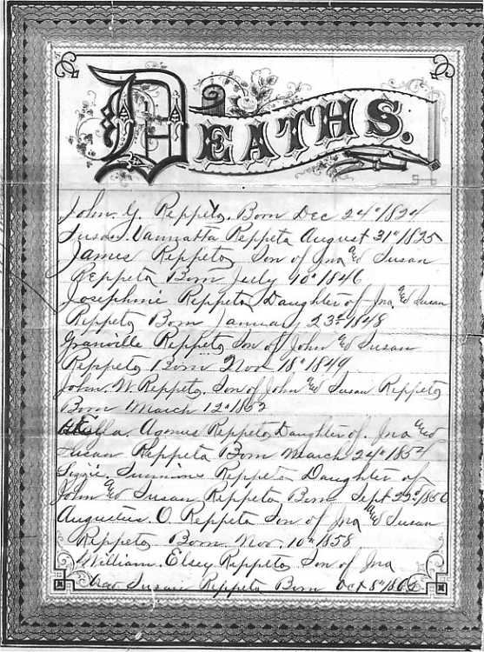
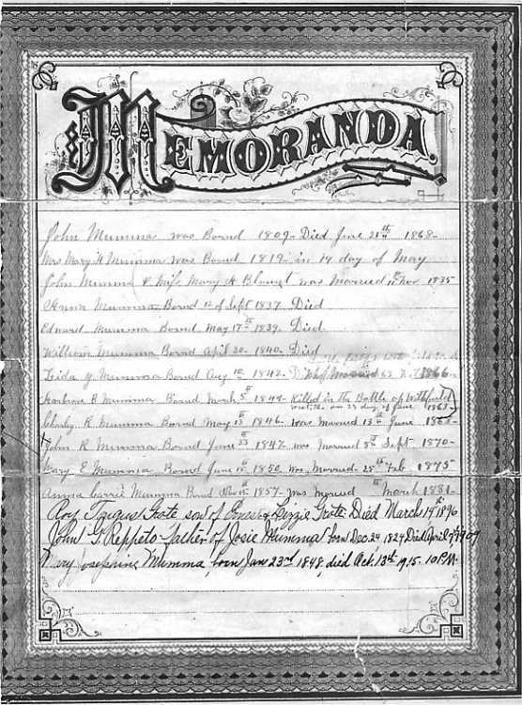
Descendants of John Mumma

2514 John Mumma b: 10 Apr 1780 in York Co., PA d: 23 Jun 1849 in Butler Co., OH
+ Ann Bare b: 10 Aug 1788 in PA d: 31 Jan 1850 in Butler Co., OH m: in York Co., PA
...25141 John Mumma b: 1809 in York Co., PA d: 21 Jun 1868 in OH
...+ Mary Ann Blount aka: Mary Ann Blunt b: 19 May 1819 in OH m: 11 Nov 1834 in Preble Co., OH
.........251411 Anna Mumma b: 12 Sep 1837 in Preble Co., OH
.........251412 Edward Mumma b: 17 May 1839 in Preble Co., OH d: Bef. 1850
.........251413 William Mumma b: 30 Apr 1840 in Preble Co., OH d: Bef. 1850
.........251414 Eliza A. Mumma aka: Leida Y. Mumma b: 10 Aug 1842 in Preble Co., OH
.........+m: 1866
.........251415 Ambrose B. Mumma b: 5 Mar 1844 in Preble Co., OH d: 23 Jun 1863 in Battle of Wittfield, Civil War
.........251416 Charles R. Mumma b: 13 May 1846 in Preble Co., OH
.........+ Margaret J. b: Abt. 1843 in OH m: 13 Jun 1868
...............2514161 Samuel Mumma b: 1873 in MO
.........251417 John Rush Mumma b: 23 Jun 1847 in Preble Co., OH d: 26 Oct 1916 in Kansas City, Jackson Co., MO
.........+ Mary Josephine "Josie" Reppeto b: 23 Jan 1848 in Maude, OH d: 13 Oct 1915 in Kansas City, Jackson Co., MO m: 8 Sep 1870 in Butler Co., OH
...............2514171 William R. Mumma b: Mar 1872 in KS
...............2514172 Elizabeth L. Mumma b: 1 Nov 1873 in MO d: 23 Jul 1933 in Kansas City, Jackson Co., MO
...............+ Ernest A. Grote b: 17 Apr 1870 in New York City, NY d: 12 Dec 1946 in Kansas City, Jackson Co., MO m: Abt. 1895 in MO
....................25141721 Roy Targus Grote b: Abt. 1896 d: 14 Mar 1896
....................25141722 Charles E. Grote b: 1903 in MO
...............2514173 Anna A. Mumma b: 22 Jan 1882 in MO d: 26 Nov 1952 in Los Angeles Co., CA
...............+ Ross Frank Barcafer b: 11 Mar 1874 in MO d: 4 Jun 1948 in Los Angeles Co., CA m: Aft. 1915
.........251418 Mary E. Mumma b: 15 Jun 1850 in Preble Co., OH
.........+m: 25 Feb 1875
.........251419 Anna Carrie Mumma b: 15 Nov 1857 in Preble Co., OH
.........+m: Mar 1881
...25142 Eliza Mumma b: Abt. 1811 in York Co., PA d: 4 Feb 1848 in Middletown, Butler Co., OH
...+ William Young b: 11 Jan 1803 in Hanover, York Co., PA d: 30 Aug 1889 in Hanover, York Co., PA m: 24 Sep 1833 in Butler Co., OH
.........251421 Mary R. Young b: Abt. 1840 in Middletown, Butler Co., OH d: 22 Jun 1876 in Milton, Northumberland Co., PA
.........+ William A. Schreyer b: 1834 in PA d: 15 Dec 1903 m: 12 Dec 1861
...............2514211 Infant Schreyer
...............2514212 Infant Schreyer
...............2514213 Maria E. Schreyer b: 1875 in Northumberland Co., PA
...............+ W. R. Kramer
...............2514214 Rebecca Y. Schreyer b: 1876 in Northumberland Co., PA
...............2514215 John Y. Schreyer b: Oct 1870 in Milton, Northumberland Co., PA
...............+ Carrie H. Smith
...............2514216 Harry H. Schreyer b: 1874 in Milton, Northumberland Co., PA
...............+ Bertha Datesman
.........251422 Amelia Ann Young b: 2 Apr 1835 in Middletown, Butler Co., OH d: 31 Aug 1835 in Middletown, Butler Co., OH
.........251423 Infant Young b: 28 Mar 1838 in Middletown, Butler Co., OH d: 30 Mar 1838 in Middletown, Butler Co., OH
.........251424 William Henry Young b: 15 Sep 1843 in Middletown, Butler Co., OH d: 20 Nov 1844 in Middletown, Butler Co., OH
.........251425 John Mumma Young b: 30 Aug 1845 in Middletown, Butler Co., OH d: Aft. 1930
.........+ Amelia Carrie Van Patten b: Sep 1848 in Washington D.C. d: 2 Dec 1923 in Gettysburg, Adams Co., PA m: 25 Aug 1868
...............2514251 William Young b: 1870 in Topeka, KS
...............2514252 Edwin P. Young b: 1872 in OH
...............2514253 John P. Young b: 1873 in OH
...............2514254 Mary E. Young b: Apr 1875 in OH
...............2514255 Charles Van Patten Young b: Nov 1876 in OH
...............2514256 George H. Young b: Jan 1878 in York Co., PA
...............2514257 Carrie Young b: Mar 1880 in York Co., PA
...............2514258 Ruth Young b: Mar 1882 in PA
...............+ Carl G. Allen b: 1883 in PA m: 1906
....................25142581 Ruth Allen b: 1907 in Williamsport, Lycoming Co., PA
....................25142582 Dorothy Allen b: 1909 in Williamsport, Lycoming Co., PA
....................25142583 Carl G. Allen, Jr. b: 1913 in Williamsport, Lycoming Co., PA
....................25142584 John M. Allen b: 1920 in Williamsport, Lycoming Co., PA
...25143 Anna Mumma b: Abt. 1814 in PA
...+ James H. Curry b: 1814 m: 23 Feb 1837 in Butler Co., OH
.........251431 Amanda L. Curry b: 1840 in Middletown, Butler Co., OH
.........251432 John Curry b: 1842 in Middletown, Butler Co., OH
.........251433 Clarra C. Curry b: Aug 1850 in Middletown, Butler Co., OH
...25144 Maria Mumma b: 15 Nov 1816 in Hanover Twp., Adams Co., PA d: 17 Dec 1858 in Butler Co., OH
...+ George J. Jacoby b: 17 Jun 1809 in Macungie, Twp., now Lehigh Co., PA d: 19 Dec 1879 in Butler Co., OH m: 17 Feb 1835 in Butler Co., OH
.........251441 William Henry Jacoby b: 7 Sep 1836 in Butler Co., OH d: 1 Apr 1839 in Butler Co., OH
.........251442 Amelia Anna Jacoby b: 20 Jul 1838 in Seven Mile, Butler Co., OH d: 5 Feb 1917
.........+ John Monfort b: 20 Aug 1826 in Monroe, OH d: 30 Dec 1863 in Woodside Cemetery, Middletown, Butler Co., OH
...............2514421 George Francis Monfort b: 23 Jun 1862 in Butler Co., OH
.........*2nd Husband of Amelia Anna Jacoby:
.........+ Marcellus Foote Waters b: 4 Apr 1829 in Clermont, OH d: 22 Feb 1903 m: Aft. 1863
...............2514422 Cora Belle Waters b: 2 Mar 1868
...............2514423 James Henry Waters b: 19 Jan 1874
...............2514424 Kittie Waters b: 14 Mar 1878
.........251443 Edwin Mumma Jacoby b: 24 Nov 1839 in Seven Mile, Butler Co., OH d: 9 Sep 1867
.........+ Mary Elizabeth Jones b: Abt. 1846 d: 26 Jun 1894 m: 30 Nov 1865
.........251444 James Henry Jacoby b: 23 May 1842 in Seven Mile, Butler Co., OH d: 13 Jul 1898
.........+ Lydia A. Lane b: 18 Apr 1844 in Middletown, Butler Co., OH d: 1 Jan 1925 in Los Angeles, CA
...25145 Amanda Mumma b: 22 Jun 1819 in PA d: 26 May 1851 in Middletown, Butler Co., OH
...+ Hiram Luther Henkel aka: Hiram Hinkle b: 15 Mar 1818 in OH d: 5 Aug 1881 in Middletown, Butler Co., OH m: 9 Nov 1839 in Butler Co., OH
.........251451 George H. Henkel aka: George H. Hinkle b: 28 Aug 1841 in Madison Twp., Butler Co., OH
.........+ Ellen Foster b: 23 Jan 1839 m: 24 Jul 1867 in Union, Boone Co., KY
...............Henkel
.........251452 John Henkel b: Abt. 1842 in Butler Co., OH
.........251453 Andrew P. Henkel b: Abt. 1844 in Middletown, Butler Co., OH d: 4 Jun 1913 in Cincinnati, OH
.........251454 Caroline Henkel b: Abt. 1846 in Middletown, Butler Co., OH
...25146 Barbara Mumma b: Abt. 1822 in York Co., PA d: Bet. 1850 - 1856 in Butler Co., OH
...+ George C. Barnitz b: 13 Jun 1812 in Hanover, York Co., PA m: 15 Aug 1841 in Butler Co., OH
.........251461 Charles S. Barnitz b: 1843 in Butler Co., OH d: 1847 in Butler Co., OH
.........251462 George Henry Barnitz b: 1848
...25147 Daniel Mumma b: 1 Oct 1824 in York Co., PA d: 19 Jul 1853 in Butler Co., OH
...+ Caroline Wetzel b: Abt. 1829 in PA m: 1 Mar 1848 in Butler Co., OH
.........251471 Florence Mumma b: 1850 in Butler Co., OH
.........251472 John Mumma b: Abt. 1852 in Middletown, Butler Co., OH d: Jan 1880 in Madison Twp., Butler Co., OH
.........+ Emma L. Gunckel aka: Emma Gweckle b: 17 Apr 1857 in Germantown, Montgomery Co., OH d: 8 Apr 1881 in Germantown, Montgomery Co., OH m: 22 Nov 1876 in Montgomery Co., OH
...............2514721 John Vernon Mumma b: 23 Sep 1877 in Butler Co., OH d: 29 Aug 1940 in San Diego, San Diego Co., CA
...............+ Susan Matilda Schweitzer b: 8 Jan 1881 in Dayton, OH d: 1 Sep 1967 in San Diego, San Diego Co., CA m: 4 Sep 1896 in Dayton, Montgomery Co., OH
....................25147211 Marion Vida Mumma b: 18 Apr 1897 in Germantown, Montgomery Co., OH d: 1924 in Germantown, Montgomery Co., OH
....................+ Harry Fredericks m: 1921 in Germantown, Montgomery Co., OH
....................25147212 Myrtle Vera Mumma b: 13 Jan 1899 in Germantown, Montgomery Co., OH d: 6 Nov 1942 in San Diego, San Diego Co., CA
....................+ Howard Swigart b: in Vandalia, OH m: 25 Aug 1917 in Dayton, Montgomery Co., OH
..........................251472121 Genevieve Swigart b: 12 Oct 1918 in Germantown, Montgomery Co., OH
..........................251472122 Vernon Henry Swigart b: 30 Jul 1921
..........................251472123 Howard R. Swigart, Jr. b: 14 Aug 1924 in Montgomery Co., OH d: 21 Feb 1997
....................*2nd Husband of Myrtle Vera Mumma:
....................+ Brown m: Aft. 1924
....................25147213 Mercedes Vivian Mumma b: 17 Jan 1901 in Germantown, Montgomery Co., OH d: 8 Oct 1970 in San Diego, San Diego Co., CA
....................+ Donald Robert McCown b: in Fayetteville, TN m: 15 Apr 1933 in Yuma, AZ
..........................251472131 Dianne McCown
..........................251472132 Donald Phillip McCown b: 6 Apr 1940
..........................+ Janet Kilbourn b: in Oregon m: in San Diego, San Diego Co., CA
....................25147214 Mabel Violet Mumma b: 27 Mar 1903 in Germantown, Montgomery Co., OH d: 14 Jan 1997 in San Diego Co., CA
....................+ Edgar M. Smith b: in Germantown, Montgomery Co., OH d: in Spring Valley, CA
..........................251472141 Ted Keith Smith b: 1 Sep 1924 in OH d: 1 Feb 1996 in San Bernardino Co., CA
..........................+ Marjorie Maynard m: 11 May 1947 in Yucca Valley, CA
..........................251472142 Gloria Starr Smith b: 15 Sep 1926 in OH
..........................+ Clifford Schrank m: 16 Jun 1950
..........................251472143 Jack Blair Smith b: 25 Apr 1929 in OH
..........................+ Winnie
....................25147215 John Doran Mumma b: 3 Apr 1905 in Germantown, Montgomery Co., OH d: 7 Jul 1960 in Las Vegas, NM
....................+ Hilda Libecap b: Abt. 1907 in OH m: 31 Dec 1928
....................*2nd Wife of John Doran Mumma:
....................+ Genevieve Whitlock b: 28 May 1922 in Axtell, UT m: 10 Oct 1944 in Reno, NV
..........................251472151 Patricia Annette Mumma b: 10 Oct 1945 in Salt Lake City, Salt Lake City Co., UT
..........................+ Robert Blettenberg b: 23 Mar 1943 in Jersey City, NJ m: 15 Jun 1966 in Salt Lake City, Salt Lake City Co., UT
..........................251472152 John Vernon Mumma aka: John Vernon Stevenson b: 25 Jul 1953 in Las Vegas, NM
....................25147216 Myrla Vernetta Mumma b: 18 Oct 1907 in Sunbury, Montgomery Co., OH d: 24 May 1995 in San Diego, San Diego Co., CA
....................+ Herbert L. Larson b: in Waseca, MN d: 1 Feb 1956 in San Diego, San Diego Co., CA m: 3 Apr 1937 in Yuma, AZ
....................25147217 Henry Eugene Mumma b: 27 Jan 1910 in Sunbury, Montgomery Co., OH d: 17 Aug 2000 in Descanso, San Diego Co., CA
....................+ Grace Freeman b: Abt. 1912 in Los Angeles, Los Angeles Co., CA m: 12 Dec 1928 in Tia Juana, Mexico
..........................251472171 Sue Carroll Mumma b: 4 Aug 1929 in San Diego Co., CA
..........................+ Albert Graham b: in San Diego, San Diego Co., CA m: 12 Jun 1949 in San Diego, San Diego Co., CA
..........................251472172 Eugene Stanley Mumma b: 12 Feb 1944 in Descanso, San Diego Co., CA d: 7 Sep 1984 in San Diego, CA
....................25147218 Meda Vee Mumma b: 14 Apr 1912 in Sunbury, Montgomery Co., OH d: 3 Apr 1942 in San Diego, San Diego Co., CA
....................+ Melton McPeak b: in San Diego, San Diego Co., CA m: 20 Apr 1941 in San Diego, San Diego Co., CA
....................25147219 Marie Varna Mumma b: 29 Oct 1914 in Sunbury, Montgomery Co., OH d: 26 Jan 1995 in Vista, San Diego Co., CA
....................+ Wilburn Rogers b: 1912 in Berryville, AR d: 19 Apr 1938 in Yuma, Yuma Co., AZ m: 1936 in Yuma, AZ
....................*2nd Husband of Marie Varna Mumma:
....................+ Melvin H. Walker b: 1912 in Galva, IL m: 12 Jul 1944 in Galva, Henry Co. IL
..........................251472191 Michael Steven Walker b: 20 Jul 1949 in Vista, CA
..........................+ Joanne Inga
....................25147210 Marlo Vane Mumma b: 16 Jan 1921 in Sunbury, Montgomery Co., OH
....................+ George C. Gross b: 1922 m: 30 Apr 1941 in San Diego, San Diego Co., CA
..........................251472101 George Timothy Gross b: 28 Mar 1951
..........................+ Marcia Adams b: in Marshall, TX m: 12 Jun 1975
..........................251472102 John Henry Gross b: 1 Feb 1954
.........251473 Mary M. Mumma b: Abt. 1854 in Middletown, Butler Co., OH d: 28 Feb 1854 in Middletown, Butler Co., OH
...25148 Ephraim Mumma b: 18 Nov 1825 d: 2 Oct 1847 in Middletown, Butler Co., OH
...+
.........251481 Ephraim Mummaugh aka: Ephraim Mumma b: Jul 1847 in OH
.........+ Dorcas H. Darling b: Nov 1853 in OH m: 22 Feb 1871 in Bryan, Williams Co., OH
...25149 David Mumma b: Abt. 1827 in York Co., PA d: 25 Apr 1879 in Butler Co., OH
...+ Elizabeth Eleanor Snyder b: 27 Aug 1829 in OH d: 31 Mar 1876 in Butler Co., OH m: 22 Nov 1848 in Butler Co., OH
.........251491 Samuel S. Mumma b: 30 Nov 1849 in Butler Co., OH d: 11 Apr 1879 in Butler Co., OH
.........+ Florence Brown b: Sep 1859 in OH
...............2514911 Harry D. Mumma b: Nov 1877 in Butler Co., OH
...............+ Mazie Gundrum b: Jun 1879 in Williamsport, Lycoming Co., PA m: Abt. 1899
....................25149111 Alice Mumma b: 1901 in Lycoming Co., PA
...............2514912 Charles Mumma b: Jul 1879 in Butler Co., OH
.........251492 James Mumma b: 16 May 1852 in Middletown, Butler Co., OH d: 8 Aug 1855 in Middletown, Butler Co., OH
.........251493 Anna M. Mumma b: 1856 in Butler Co., OH
...25140 Adam Mumma b: 23 Sep 1828 d: 14 Sep 1834 in Middletown, Butler Co., OH
...2514a James Mumma b: Abt. 1830 d: 8 Aug 1833 in Middletown, Butler Co., OH
...2514b Emelia Mumma b: 31 Mar 1832 in Middletown, Butler Co., OH d: 8 Aug 1833 in Middletown, Butler Co., OH

